Generic Methods

These methods behave the same behaviour on different data types. Data type is decided at the time of compilation time.

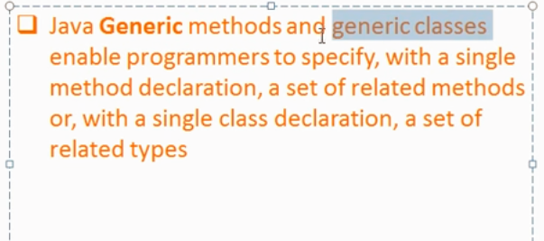

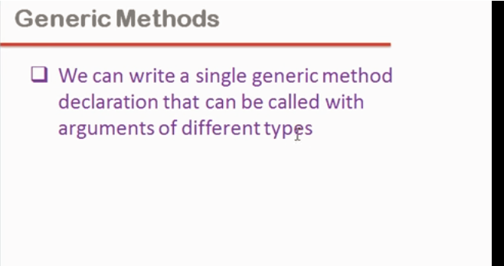

Generic methods are used in order to avoid the overriding methods. Below is an example of overriding methods;

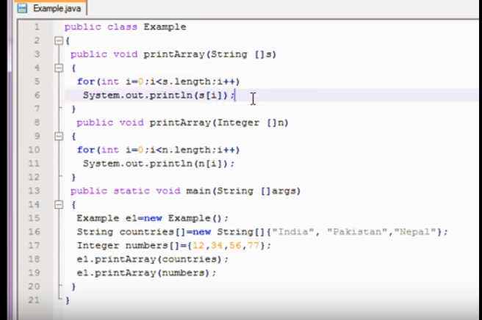

Below is an example of generic methods;

